BOARD
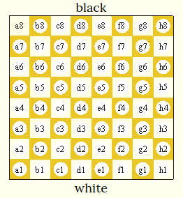Squares names
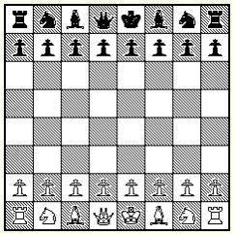
Initial Setting

GENERAL RULES

- Board must be laid down such that there is a dark square in the lower-left corner.
- Each player’s queen always starts on a square of its own color.
- The player using the white pieces moves first.
- Players take turns moving one piece each according to the piece’s movement rules.

Taking

- A player takes an opponent’s piece by moving one of their own pieces to the same square as the opponent’s piece.
- The taken piece is removed from the board, and out of play for the rest of the game.
- Taking is not compulsory.
PIECES MOVEMENT

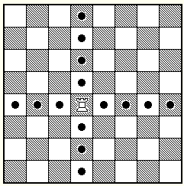Rook
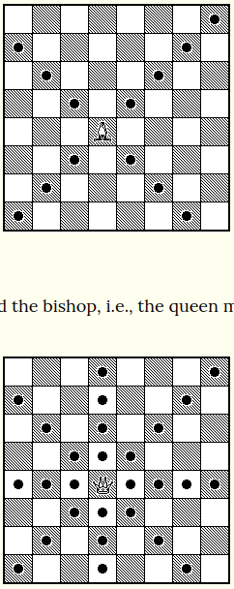Bishop

Queen
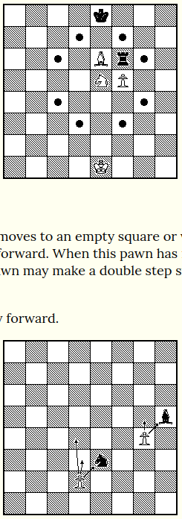Knight

Pawn
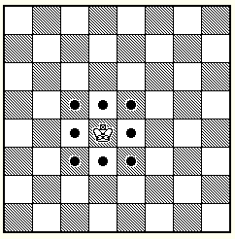King

CHECK, CHECKMATE AND STALEMATE

Check | When the king of a player can be taken by a piece of the opponent
Checkmate | When a player is in check and they cannot make a legal move
Stalemate (Draw) | When a player is not in check and they cannot make a legal move

LEGAL MOVE: A move after which the king is not in check.

WAYS TO REMOVE A CHECK

- Move the king to a square in which he is no longer in check
- Take the piece that gives the check
- Move the a piece between the king and the checking piece (only if checking piece is a rook, a bishop or a queen).

SPECIAL RULES

- When a pawn reaches the opposite end of the board it can be “Promoted”, which means that it can be made into a Queen, Knight, Rook or Bishop of the same color.
- Pawns can move two squares forward only on their first move.
- “En passe” taking.
- Castling.

